Ipswich Community Gallery
Exhibition Application Package
2023-2024

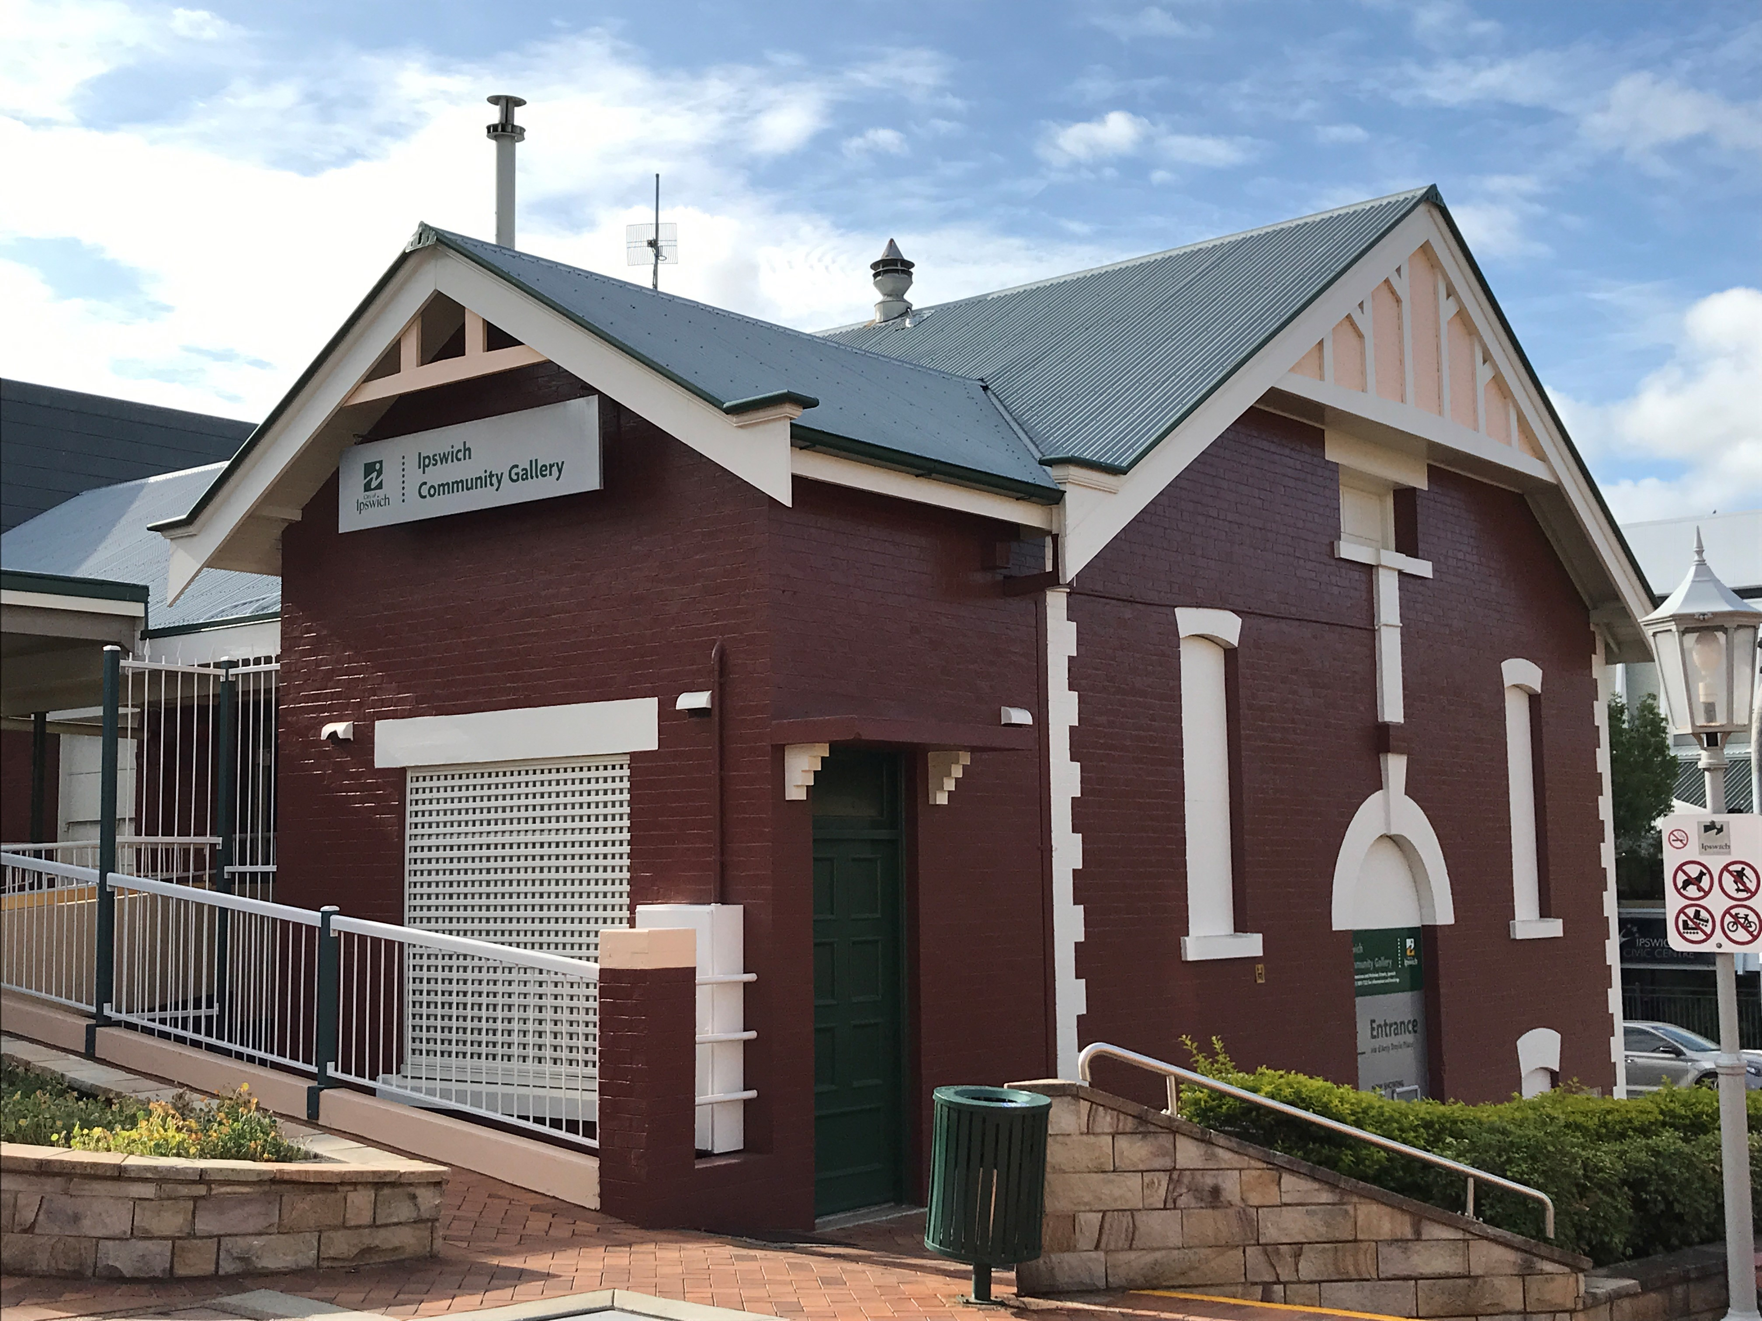


d’Arcy Doyle Place
Cnr Limestone & Nicholas Streets
IPSWICH QLD 4305
Ph: 07 3810 7222

About the Ipswich Community Gallery
The Ipswich Community Gallery is an active arts space with a focus on connecting local emerging artists, arts professionals and arts groups. As a council-owned venue available for hire, the Ipswich Community Gallery is an accessible and welcoming space open to supporting a variety of arts-based initiatives. Presenting a dynamic and curated program of events, the Ipswich Community Gallery strives to fundamentally support arts and culture by providing opportunities for artists of all abilities.
Programs in the Community Gallery include opportunities for solo and group exhibitions, workshops, professional development sessions, pop up activities and collaborative community events.
The gallery forms an important steppingstone for emerging and early career artists as an entry point into professional practice.
Amateurs or professionals alike may apply to hire the Ipswich Community Gallery. Applications are processed in the order of submission. Assessment of applications is based primarily on availability of the space as well as the suitability of the activity for the venue and the community.
Cost:
A hire fee is payable for use of the Ipswich Community Gallery. Hire fees cannot be waived under any circumstances. The hire fee is $110.00 (including GST) per week in accordance with Council’s Fees and Charges 2023-2024. The minimum hire period is one (1) week with a maximum hire period of four (4) weeks (including installation and demount time).
https://www.ipswich.qld.gov.au/services/planning-and-property/building/fees_charges
Location:
The Ipswich Community Gallery is located in d’Arcy Doyle Place, on the corner Limestone and Nicholas Streets, Ipswich, Queensland 4305.

How to Apply:
Please read through the Terms and Conditions of Hire before completing an Application form to be submitted through to info@ipswichartgallery.qld.gov.au for consideration.
Applicants will be notified of the outcome of their application within 1 month of receipt of the application. If you require assistance to complete your application, please phone: 07 3810 722
Alternatively, you can mail your submission to our postal address.
Post: Exhibitions & Collection Officer, Ipswich Art Gallery
Ipswich City Council, PO Box 191, Ipswich Qld 4305

Specifications and dimensions:
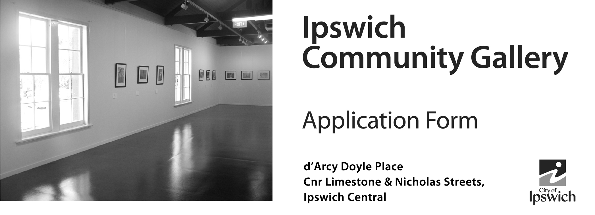
The Ipswich Community Gallery is equipped with a track hanging system, basic exhibition lighting and vinyl floor. The Gallery has a lockable storage area containing exhibition plinths, plastic stacking chairs and fold-out tables. A lectern is also available. In addition, there is a kitchenette with fridge and tea/ coffee making facilities. Toilet facilities are shared with Jamie’s Ministry of Food and can be accessed with security swipe.
Exhibition Area Floor Space:
128.7 MSQ

Floor Loading:
250kg per square meter

Hanging Wall Space:
34.5 metres

Hanging Track Height:
2.98 metres from floor

Ceiling Height:
2.98 metres from floor to bottom of exposed beams and fluorescent light fixtures

Roof apex is approx. 7 metres from the floor

Entry Door:
2.46 metres high
x 1.56 metres wide



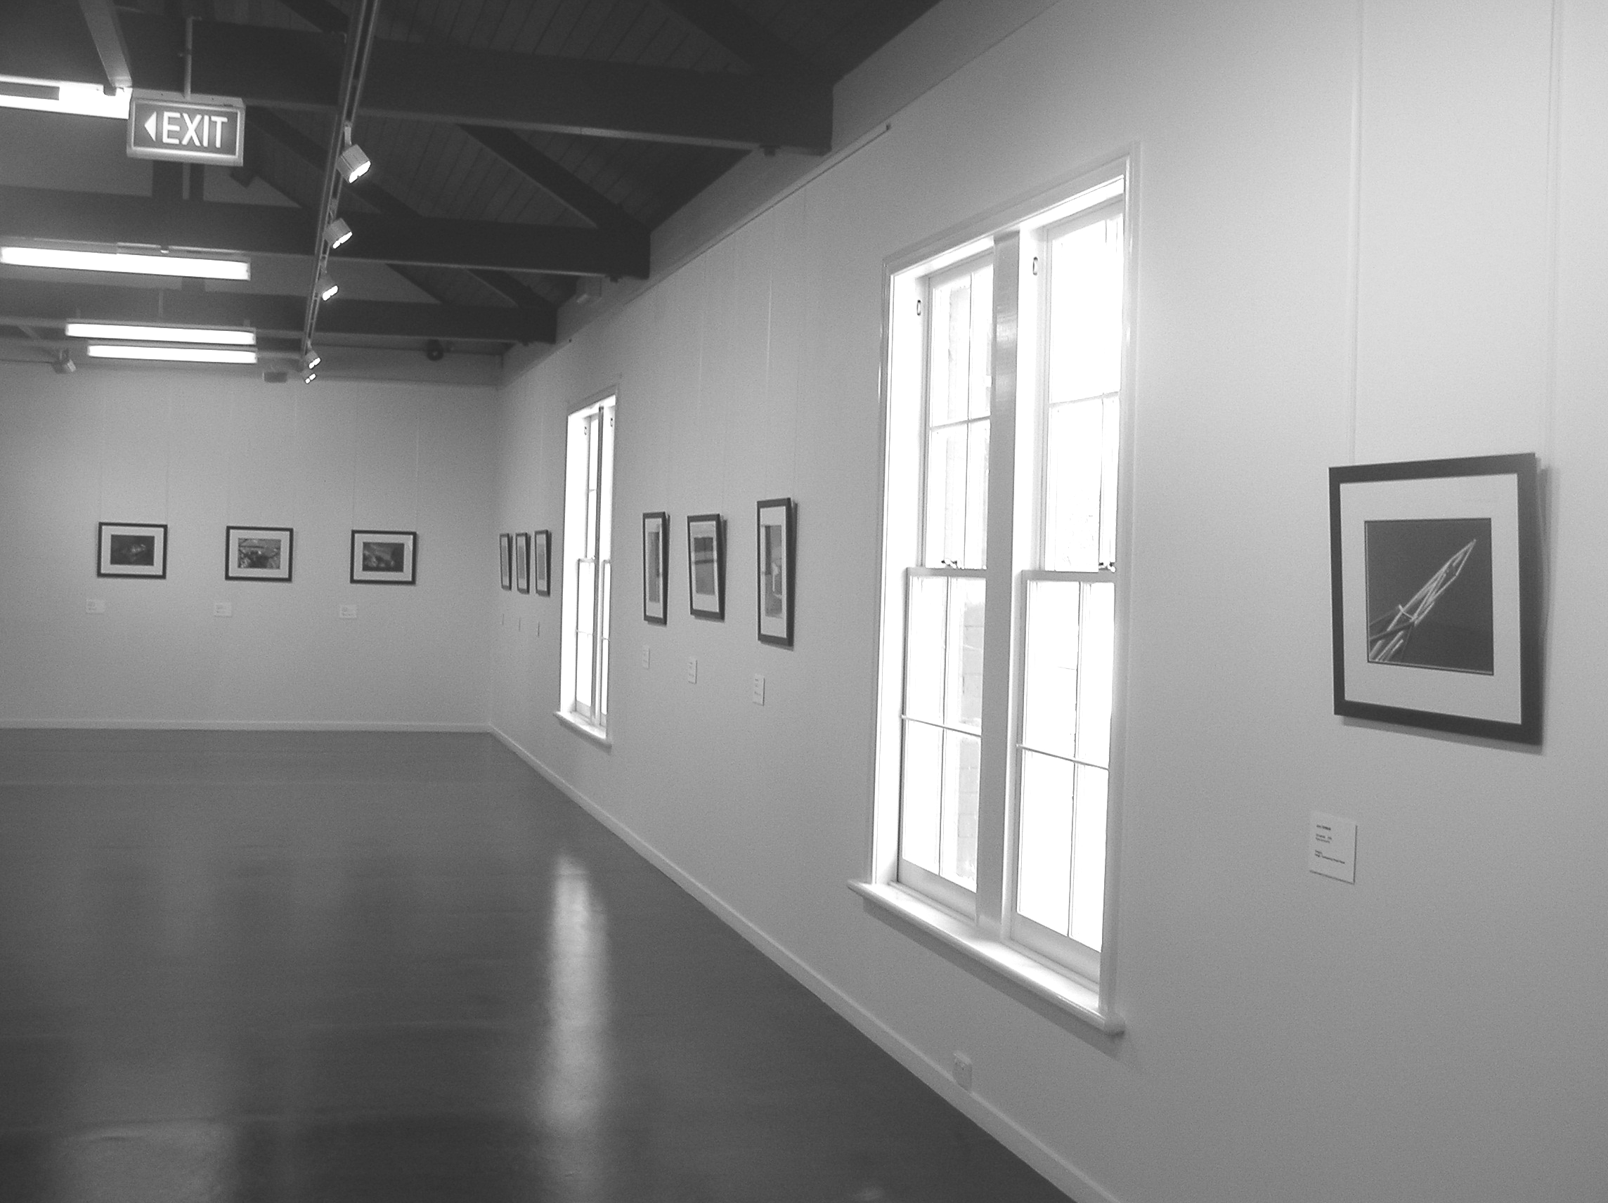

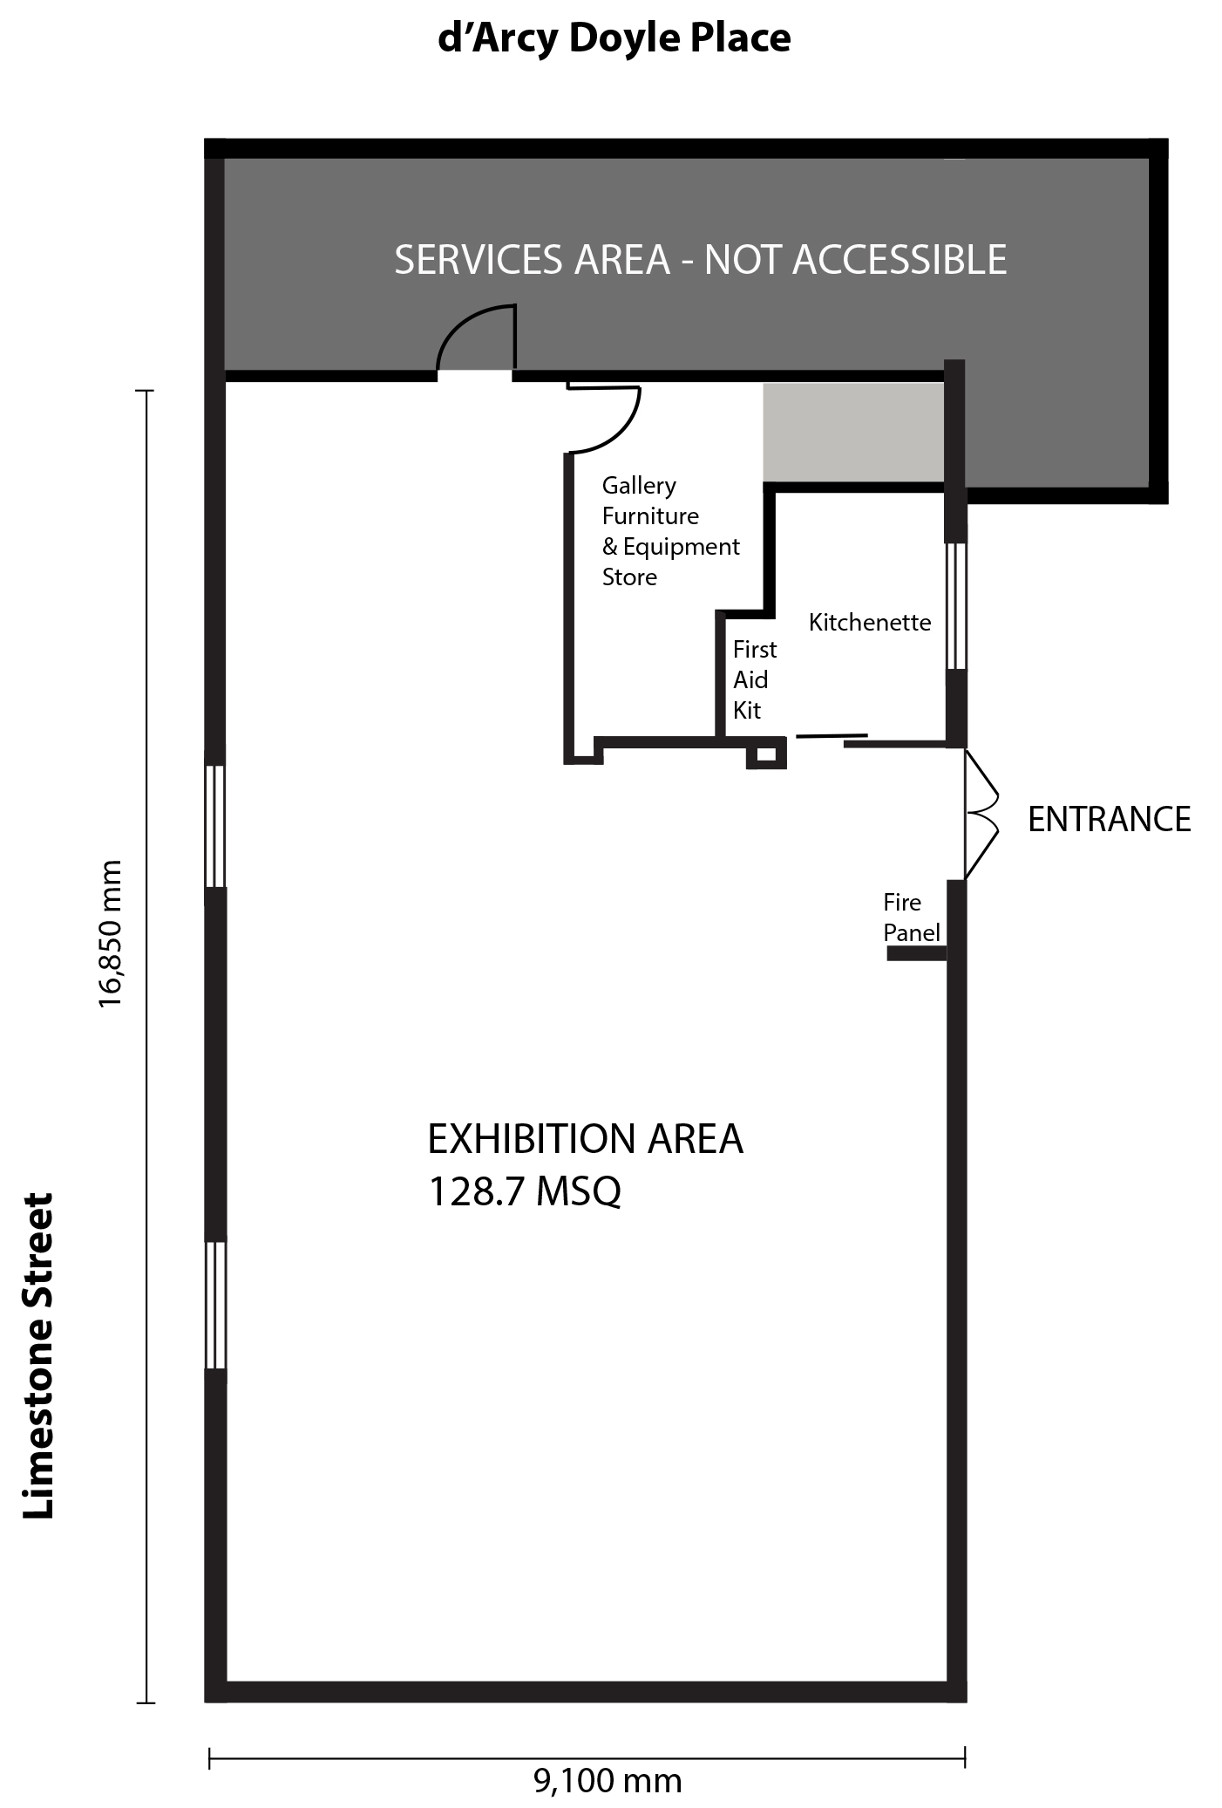

Ipswich Community Gallery Terms and Conditions of Hire

Definitions
‘Council’ Ipswich City Council
‘Hirer’ the person contractually obligated by the Hire Agreement
‘Venue’ the Ipswich Community Gallery

General Conditions of Hire
  - The Venue shall not be sublet or assigned to a third party unless the Council has given prior written approval.
  - The Hirer must only use the Venue for the purpose stated in the Application and Hire Agreement.
  - The entry doors to the Venue are to be locked, and the security system armed upon leaving at the end of each day.
  - The Hirer will ensure that the following conditions of use are maintained:
    - No smoking is permitted inside the Venue or d’Arcy Doyle Place at any time.
    - No dangerous goods are to be brought into the Venue.
    - No items in the Venue are to exceed the floor load limit (not more than 250 kg per square metre).
    - Any equipment brought in by the Hirer is the responsibility of the Hirer and any electrical equipment must carry a current safety tag.
    - The Hirer and their nominees are to be aware of the emergency evacuation procedures.
    - All workplace health and safety directions issued by Council are to be followed.
    - Access to the Ipswich Art Gallery loading dock is prohibited at all times.
    - Access to adjacent buildings and d’Arcy Doyle Place is not to be blocked at any time.
  - Council reserves the right to cancel any exhibition, activity or event which, in the opinion of Council, may jeopardise public safety or security, are exploitative or which may cause undue offence to the community or to particular community groups. Council retains the right to remove offensive material, or to demand that appropriate warning of such material be provided to visitors through signage. Council reserves the right to prohibit exhibitions, activities or events which conflict with the scheduling or audience development objectives of any Council program.

Fees and Charges
  - The Hirer must pay a hire fee for the use of the Venue for the hire period as set out in Council’s
Register of Fees and Charges [ipswich.qld.gov.au/residents/building/fees_charges].
  - An invoice for the hire fee will be issued directly by Council with payment due in 7 days. To confirm the booking, a Hirer must pay the fee as invoiced by the due date. Failure to pay the fees when required will result in cancellation of the booking.
  - Council reserves the right to charge additional fees for repairs and excess cleaning incurred as a result of the Hirer’s negligence or wilful damage. Where such fees are to be charged, it will first be discussed with the Hirer.

Cancellations and Delays
  - The Hirer may cancel their booking at any time by giving notice in writing to Council (email will suffice). Should a booking be cancelled by the Hirer, any hire fee paid will not be refunded.
  - To avoid cancellation of the booking, the Hirer may opt to reschedule their booking to another time. The booking must be rescheduled (subject to availability) to a date within 90 days of the initial booking commencement date in order to avoid being cancelled. The Hirer may only opt to reschedule a booking once. If it is unable to be rescheduled, the booking will be cancelled and any hire fee paid will not be refunded.
  - If Council cancels the booking under the provisions of clause 1(e), Council will not refund the hire fee paid to date.
  - Should Council need to cancel the booking due to circumstance beyond its control, Council will refund the hire fee paid by the Hirer. Alternatively, Council will make every effort to reschedule the booking at a time mutually suitable to Council and the Hirer.
  - Neither Council nor the Hirer accept liability for “unavoidable delays” if caused directly or indirectly by an act or event that is beyond the reasonable control of either party (such as fire, flood, earthquake, Acts of God, riot, rebellion or revolution).
  - Where such delays occur both Council and Hirer agree to explore reasonable options and alternatives to reschedule the booking at a time or venue mutually suitable to Council and the Hirer.
  - Where the delay forces cancellation of the booking by Council, Council will refund the hire fee paid by the Hirer to date.

Liabilities and Insurances
The Hirer acknowledges that:-
  - The Hirer and their nominated assistants use the Venue at their own risk.
  - Council is not liable for any action, demand, obligation, damage, penalty or other liability of any kind (whether suffered by or against you, Council or someone else) arising directly or indirectly in respect of any of the following:
    - A breach of this Agreement by the Hirer,
    - Acts, omissions and conduct of the Hirer/ Group members, and/ or their nominated assistants,
    - Your use of, or presence at the Venue,
    - Any act, omission, conduct or occurrence in respect of which you are responsible under the hire agreement.
  - The Hirer agrees to indemnify Council and keep Council indemnified against any action, demand, obligation, damage, penalty or liability described above.
  - Council will not be liable in any event (whether in contract, tort or otherwise) for any consequential, indirect, incidental, special, punitive or exemplary damages, including without limitation any loss of profits or loss of goodwill or economic loss in relation to the Hirer’s use of the Venue.
  - Council will not be liable for any loss or injury to any person or property occurring in relation to the
Hirer’s use of the Venue.
  - The Hirer is responsible for obtaining the relevant insurances in relation to the use of the Venue, including:
    - Insurance of exhibition, performance, activity materials and personal belongings,
    - Professional indemnity insurance (if required),
    - Public liability insurance,
    - Personal accident insurance (if required),
    - OR accepts all liabilities/ risks in relation to their use of the Venue.
  - The Hirer should seek independent legal advice in respect of liabilities and insurances.

Responsibilities of the Hirer
The Hirer is responsible for:
  - All costs associated with the creation and presentation of the exhibition, event or activity.
  - Transport of all material to and from the Venue.
  - Installation and/ or bump-in at the commencement of the hire period.
  - Development and production of any accompanying signage, labels and information panels.
  - Promotion of the exhibition, event or activity including invitations, advertisements, social media posts and media liaison.
  - Using the existing hanging system or other display mechanism. (NB nailing into the walls and use of Velcro, double-sided tape, screws are prohibited.)
  - Booking an orientation on the use of the Venue prior to commencement of the hire period. (The purpose of this orientation is to ensure that the Hirer is briefed and is aware of the use of security access cards, security system schedule, emergency evacuation procedures, fire extinguishers and the location of the first aid kit. This information must be distributed to all of the Hirer’s nominated assistants that will be in the Venue during the hire period.)
  - Keeping the Venue clean and tidy including the kitchen and any outside areas used. (Basic cleaning by Council staff is undertaken each weekday morning when the Venue is in use.)
  - Notifying Council in the event of any damage and/or injury as soon as practical.
  - Safekeeping the security access card/s issued to them in order to access the Venue for the duration of the hire period. If any card assigned to the Hirer is lost/damaged/stolen the Hirer must notify Council immediately.
  - Supervision of the Venue to allow public access to the exhibition, event or activity. (Hours may be at the discretion of the Hirer, subject to approval by Council).
  - Obtaining a ‘blue card’ when working with children and to ensure that all representatives, contractors or agents used by the Hirer at the Venue comply with the Child Protection Act Qld and all of the related child protection legislation at all times during their use of the Venue.
  - Handling any sale of items from the exhibition, including delivery of items to buyer (items cannot be left at the Venue for collection).
  - Adherence to the Venue’s emergency evacuation procedures as outlined at the orientation.
  - Ensuring the Venue’s entry doors remain closed as much as possible in order to maintain air- conditioning temperature and humidity levels inside the Venue.
  - Demounting/ bumping-out the exhibition, event or activity materials by the conclusion of the hire period and removing all material, signage and rubbish from the Venue at the end of the hire period.
  - Returning the Venue and equipment to its original state at the end of the hire period and returning the security access card to the Ipswich Art Gallery by 5pm on the final day of the hire period.

Responsibilities of Council
The Council is responsible for
  - Provision of the Venue (including free utilities) for the use of the Hirer during the hire period.
  - Provision of security access card/s to access the Venue.
  - Provision of an orientation on the use of the Venue prior to commencement of the hire period.
  - Provision of basic display plinths and hanging system to install exhibitions.
  - Provision of kitchenette facilities and basic function equipment such as chairs, tables and lectern.

Opening Event
The Hirer is responsible for:
  - Associated costs and organisation of any opening event, including catering and guest speakers.
  - Acquiring a liquor licence for the sale or consumption of liquor (if required), and providing a copy of any liquor licence to Council.
  - Consulting with Council to set the event date and time to ensure adequate access and security.
  - Negotiating access to appropriate toilet facilities for event guests.
  - Complying with all legislation in relation to Food Hygiene and Responsible Service of Alcohol. (Refer also to Covid Safe Framework Requirements.)
  - Ensuring that the small courtyard outside the Venue is cleaned (if utilised).
If the Hirer wishes to use the larger rotunda located in d’Arcy Doyle Place adjacent to the Venue, then an online application needs to be completed via Council’s Website: https://www.ipswich.qld.gov.au/explore/parks_reserves_precincts/permit_information/application-for- use-of-parks-and-facilities?parkname=d%E2%80%99Arcy+Doyle+Place
- Covid Safe Framework Requirements
The Public Health and Social Measure linked to vaccination Direction was revoked on 14 April 2022, ending the requirement to check-in and to be fully vaccinated in a range of venues and events. Please keep up to date with the current Queensland Government requirements, as they may change from time to time in response to the declared public health emergency. For example, there may be changes to rules around mask wearing, proof of vaccination, capacity restrictions, etc.
a. In the event that Federal or State governments and their respective regulatory bodies determine that
further or additional restrictions are required, the Hirer agrees to ensure compliance. If the exhibition,
activity or event is unable to proceed as booked due to additional restrictions, then both the Hirer and
Council will endeavour to move the hire period to a mutually agreeable time without financial or other
penalty.

Disputes
Resolutions of differences are to be sought in the first instance through negotiation between the Hirer and Council. Should any non-negotiable dispute arise concerning these terms and conditions, the dispute will be referred to a mediator appointed by the President of the Queensland Law Society for mediation.
Ipswich Community Gallery Hire Details
Name of Hirer / Group Name
Group contact Person
Postal Address

Phone (Daytime) _____________________________ (Mobile) ___________________________________
Email
Purpose of Hire (50 words max - Please provide a brief description of the exhibition/performance/activity)

Hire Period
A hire period is from Wednesday to Tuesday. Delivery, install and removal must be within the hire period.
Hire Period Start Date (Wednesday)
Hire Period End Date (Tuesday)
Hire Period Number of Weeks
Do you have the appropriate insurance/s? Yes / No
Are you planning to hold an opening event/s? (If yes, please provide details below) Yes / No
Date__________________________ Start time __________________ Finish time
Date__________________________ Start time __________________ Finish time

Are there any public programs or workshops you would like to run alongside your hire period?
(For example, an artist talk event, workshop, poetry reading, morning tea)

Would you like the gallery to promote your work on social media? _______________________________
(Provide your website, Instagram or social media links)
____________________________________________________________________________________
I have read and agree to the Terms & Conditions and I am familiar with the requirements of the
Covid Safe Framework Yes / No

Applicant’s signature _____________________________________________ Date

Ipswich Art Gallery, Ipswich City Council is collecting your personal information so that we can assist you with your enquiry. We will not disclose your personal information outside of Council unless we are required by law or you have given your consent. By completing and signing this form and returning it to Council, we will consider that you have given us your consent to manage your personal information in the manner described in Council’s Privacy Statement, Personal Information Digest and this collection notice. For more on Council’s Privacy Policy go to http://ipswichartgallery.qld.gov.au/privacy-policy.

